Workshop 5: SQL Online Music Store
Database Schema
The database consists of the following tables:
1. Artists
- artist_id (INTEGER, Primary Key)
- artist_name (TEXT)
- genre (TEXT)
- country (TEXT)
- active_since (DATE)

CREATE TABLE Artists (
artist_id INTEGER PRIMARY KEY
NOT NULL,
artist_name TEXT,
genre TEXT,
country TEXT,
active_since REAL
);
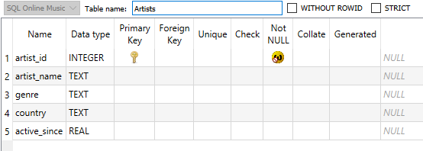

2. Songs
- song_id (INTEGER, Primary Key)
- title (TEXT)
- artist_id (INTEGER, Foreign Key to Artists)
- album (TEXT)
- release_date (DATE)
- duration_seconds (INTEGER)
- popularity_score (INTEGER)

CREATE TABLE Songs (
song_id INTEGER PRIMARY KEY
NOT NULL,
title TEXT,
artist_id INTEGER REFERENCES Artists (artist_id) ON DELETE RESTRICT
NOT NULL,
album TEXT,
release_date REAL,
duration_seconds INTEGER NOT NULL,
popularity_score INTEGER
);

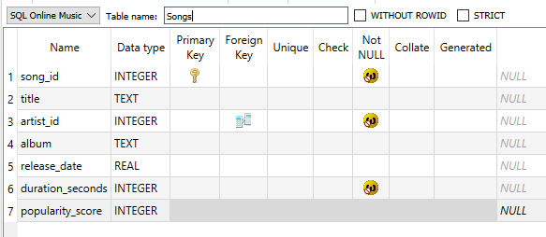

3. Customers
- customer_id (INTEGER, Primary Key)
- first_name (TEXT)
- last_name (TEXT)
- email (TEXT)
- join_date (DATE)
- premium_member (BOOLEAN)

CREATE TABLE Customers (
customer_id INTEGER PRIMARY KEY
NOT NULL,
first_name TEXT,
last_name TEXT,
email TEXT,
join_date REAL,
premium_member TEXT
);

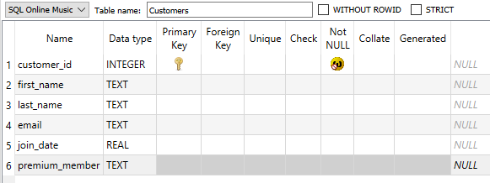

4. Purchases
- purchase_id (INTEGER, Primary Key)
- customer_id (INTEGER, Foreign Key to Customers)
- song_id (INTEGER, Foreign Key to Songs)
- purchase_date (DATE)
- price (DECIMAL)

CREATE TABLE Purchases (
purchase_id INTEGER PRIMARY KEY
NOT NULL,
customer_id INTEGER REFERENCES Customers (customer_id) ON DELETE RESTRICT
NOT NULL,
song_id INTEGER NOT NULL
REFERENCES Songs (song_id) ON DELETE RESTRICT,
purchase_date REAL,
price INTEGER
);

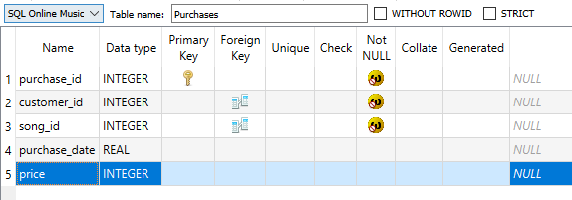

5. Streams
- stream_id (INTEGER, Primary Key)
- customer_id (INTEGER, Foreign Key to Customers)
- song_id (INTEGER, Foreign Key to Songs)
- stream_date (DATE)
- stream_time (TIME)

CREATE TABLE Streams (
stream_id INTEGER PRIMARY KEY
NOT NULL,
customer_id INTEGER REFERENCES Customers (customer_id) ON DELETE RESTRICT
NOT NULL,
song_id INTEGER REFERENCES Songs (song_id) ON DELETE RESTRICT
NOT NULL,
stream_date REAL,
stream_time REAL
);
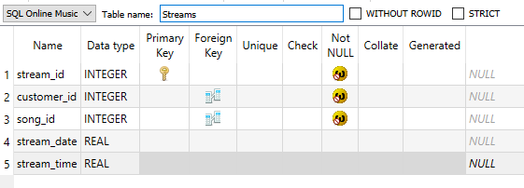

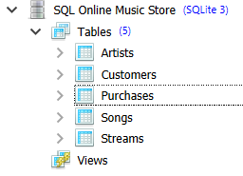

Workshop Tasks
Using the schema above, write SQL queries to answer the following questions:
- Basic Selection: Retrieve the titles and release dates of all songs released in 2022, ordered by release date (newest first).
SELECT title,
release_date
FROM songs
WHERE release_date like '%2022%'
ORDER BY release_date DESC;
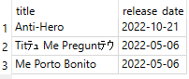
- Filtering: Find all songs with a popularity score greater than 80 and a duration less than 4 minutes (240 seconds).
SELECT song_id,
title,
popularity_score,
duration_seconds
FROM songs
WHERE popularity_score > 80 AND
duration_seconds < 240;

31 songs:
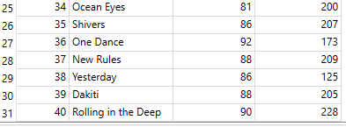

- Pattern Matching: List all artists whose names start with "The".
SELECT artist_id,
artist_name
FROM Artists
WHERE artist_name LIKE 'The%';
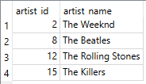

- Multiple Conditions: Find all premium customers who joined in 2022.
SELECT customer_id,
first_name,
last_name,
join_date,
premium_member
FROM Customers
WHERE premium_member = 'true' and join_date like '%2022%';
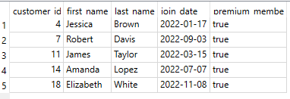
- Calculations and Aliasing: Calculate the total duration (in minutes) of all songs in the database and display the result with an appropriate column name.
SELECT song_id,
title,
artist_id,
duration_seconds/60 AS 'Total Duration'
FROM Songs;
40 results

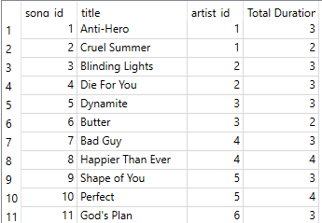
- Advanced Filtering: Find the top 5 most expensive song purchases in the database.
SELECT purchase_id,
song_id,
price
FROM Purchases
order by price desc
LIMIT 5;
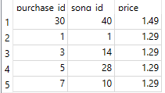
- Using Multiple Tables Separately: First, find all song_ids from songs with a popularity score above 90. Then, use those song_ids to find purchases of those songs.
SELECT song_id,
title,
artist_id,
popularity_score
FROM Songs
where popularity_score > 90 and song_id in(select song_id from purchases);

12 Results:
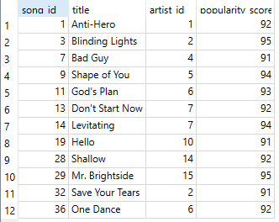

- Range Checking: Find all purchases made between January 1, 2023 and March 31, 2023.
SELECT purchase_id,
customer_id,
song_id,
purchase_date
FROM purchases
WHERE purchase_date BETWEEN '2023-01-01' and '2023-3-31';
29 Results
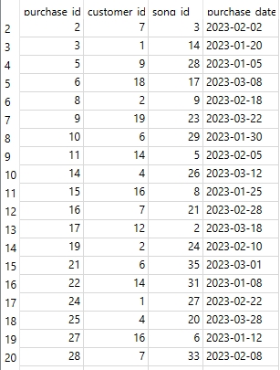
- Advanced Filtering with ORDER BY: Identify the songs with the highest popularity scores (above 90).
SELECT song_id, title, artist_id, popularity_score
FROM Songs
WHERE popularity_score > 90 order by popularity_score DESC;
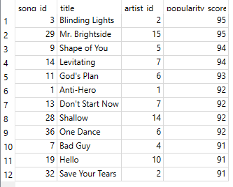

Discussion Questions
- In our database design, we separated purchases and streams into different tables. What are the benefits of this approach versus having a single "user_interactions" table?
Purchasing a song is a 1 time event. Streams can have multiple results. They both become attributes to separate tables for measuring customer interactions.

- Based on the provided data model, what business questions could music executives answer using SQL queries that we haven't covered in our exercise?
SQL can be used to quantify:
-How many times customer listen to the same song.
-How many songs each customer purchases.
-Premium vs non-premium purchases.
-How many purchases an average customer makes since joining.
-How much customer’s spend on average.

- How would you extend this schema to track more detailed user behavior, such as when users skip songs or how much of a song they listen to before skipping?
Streams: Add song_skipped (Boolean)
Add song_end (Integer)
Customers: Add zip

- For tasks 1-3, how could you combine them into a single, more complex query that finds popular short songs by artists whose names start with "The"?
SELECT song_id, title, artist_id, popularity_score, duration_seconds
FROM Songs
WHERE title like 'The%' order by popularity_score DESC, duration_seconds DESC;

